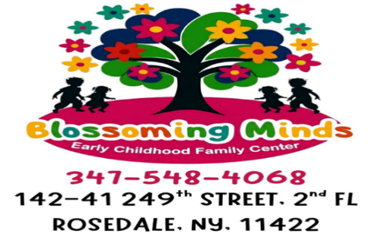

“Where Children Thrive, Learn through Play,
and Wonders and Extraordinary Awaits”



Welcome to Blossoming Minds Early Childhood Family Center After School Program! This program was created to provide families with exceptional after school care 6 years old to 12 years old (School Age/After School). We strive to meet the diverse needs of each student. We understand a parent’s need to choose a quality program that is conducive to their students’ learning and development. Blossoming Minds Early Childhood Family Center After School Program staff consider it imperative to provide the highest quality childcare and education.
At Blossoming Minds Child Early Childhood Family Center After School Program, we have well-trained, certified, and supportive teachers/caregivers who maintain the standards of our early childhood education model. This model provides the foundation for reading, writing, and math, all while promoting the social emotional skills that prepare our students for later success in school life. Our program is successful because we encourage parental involvement. This partnership is crucial for the development of every student. We offer a program adapted to the age and proportion of students: adults are always kept in each of the classrooms. Nutritious snacks are served along with homework/assignment assistance. We are truly committed to the well-being of our students.
At Blossoming Minds Child Early Childhood Family Center, we are still here for your After-Schooler/School Ager needs. Our After-School programming offers families a safe and familiar alternative. The learning continues on-site/playground for daily outdoor play, small group activities, and large group activities. For the safety of our after-school students, our After-Schoolers/School Agers are always supervised.
We appreciate that you have chosen our group family day care to meet your After Schooler/School Ager childcare needs and you can guarantee that you have made the right choice!

Nequan LaCroix – Owner/CEO
Natasha Christopher - M.S Ed. & M.S Ed. (SPED) Co-Owner/CFO/COO



“Where Children Thrive, Learn through Play,
and Wonders and Extraordinary Awaits”

Mission Statement
Our mission is to provide childcare for students aged 6 weeks to 12 years, in a safe, nurturing, and stimulating learning environment. This environment encourages students to explore, experiment, discover, play, and interact, while developing their own personal understanding of the world and themselves. Our experienced staff act as positive role models for our attending students and community. We offer a child-centered, multicultural learning environment, where every student is treated as an individual with diverse needs and interests that are to be respected and supported through developmentally appropriate practices. We realize the importance of a multi-sensory approach for young learners that enables them to plan, create, build, organize, and make personal discoveries. Play is significant in our program because it is how students learn to express themselves, take turns, share, imitate, and exchange ideas and knowledge with others. Our students have many play opportunities throughout each day. We foster a strong sense of self and aid our students in establishing healthy social relations with peers as well as adults.
Philosophy
At Blossoming Minds Early Childhood Family Center After School Program, we believe in the value of human diversity and fair treatment of all people. It is our number one goal to provide the kind of influence that encourages all students to become creative, independent, responsible, self-directed adults who can make sound decisions for themselves.
It is also important for a student to have experiences by themselves, with other students, and adults, in a safe, positive, and accepting atmosphere. This will create space and opportunity for the students to be able to explore the limits of their environment and their natural abilities. Our program encompasses the belief that parents are vital to each student’s success. We support a maximum amount of continuity between home and school.
We provide parent resources and information to address their needs. We strive to meet the needs of each individual child’s social, physical, intellectual, creative, and emotional (S.P.I.C.E) growth. Our belief is that students deserve a nurturing, safe, and happy environment, which promotes their natural curiosity and desire to learn. Students are encouraged to assist in daily class tasks, so they develop a positive self-image. All students are welcome regardless of race, creed, national origin, or gender.

“Where Children Thrive, Learn through Play,
and Wonders and Extraordinary Awaits”

Statement of Goals
At Blossoming Minds Child Early Childhood Family Center After School Program, we provide convenient, dependable, educational services for the students and the community. We provide a safe, nurturing environment with a stimulating, hands-on approach to learning. Our qualified, caring staff act as positive role models and help prepare students for success in later years.
This promotes their social/emotional, physical, cognitive, and language development. Each student is encouraged and given opportunities daily to choose and control his/her own activities under the supervision of our teachers/caregivers. Through this support, each student can establish decision-making skills and a sense of responsibility for self and their own actions.
Our policy of positive communication and positive discipline reinforces self-worth and confidence. Our teacher’s/caregiver’s role is to invite, challenge, and promote knowledge. Continuous staff training serves to keep our educators well informed and aids in the implementation of our goals. We strongly encourage parent participation and communication through parent-teacher meetings. We realize that the key to a student’s success in school is the positive connection that is developed between parents and teachers/caregivers.

“Where Children Thrive, Learn through Play,
and Wonders and Extraordinary Awaits”

VOUCHER PAYING STUDENTS ENROLLMENT APPLICATION
AFTERSCHOOL/SCHOOL AGE
Check all that applies: ( ) FULL – TIME ( ) HALF DAY, Time: _________
My Child will have ( ) Breakfast ( ) Lunch ( ) Morning Snack ( ) Evening Snack

CHILD’S INFORMATION
Child’s Name: __________________________________________________ Gender: __________ SSN: ________________________
Home Address: _________________________________________________ State: _________ Zip: ________ Home #: ___________
Child’s Doctor: _________________________________________________ Doctor’s Phone #: _______________________________
Referred By: ____________________________________________________ Last School Attended: ___________________________
Date of Birth: ______________________________ Age: ______________ Nosebleed/Asthma: _______________________________
Potty Trained: ______________________________ Allergies: ____________________________________________________________

PARENT’S INFORMATION
Parent 1 Name: _______________________________________________________ Parent’s Cell: _____________________________
Parent’s Address_________________________________________________________________________________________________
Occupation: ___________________________________________________ E-mail: __________________________________________
Employer: ______________________________________________________ Employer’s Number: _____________________________
Employer’s Address: _____________________________________________________________________________________________

PARENT’S INFORMATION
Parent 1 Name: _______________________________________________________ Parent’s Cell: _____________________________
Parent’s Address_________________________________________________________________________________________________
Occupation: ___________________________________________________ E-mail: __________________________________________
Employer: ______________________________________________________ Employer’s Number: _____________________________
Employer’s Address: _____________________________________________________________________________________________

EMERGENCY CONTACT INFORMATION

Emergency Name: ___________________________________________ Emergency Phone: __________________________________

Emergency Name: ___________________________________________ Emergency Phone: __________________________________

Emergency Name: ___________________________________________ Emergency Phone: __________________________________

Tuition:
Upon enrollment, a non-refundable registration fee of $75.00 per child is required along with your voucher. Registration fees are non-refundable. Thereafter, if your voucher is not covering the weekly tuition/fees $300 payments are due promptly on (Monday) the first day of the school week. If tuition/fees are not received by the (Tuesday) of the week, you will be charged a $50.00 late fee. If the tuition/fees balance goes into a new month, an additional $75.00 fee will be charged. ABSOLUTELY NO PERSONAL CHECKS, MONEY ORDERS, CREDIT CARDS, OR REWARD CARDS! ONLY CASH/ZELLE/ACS VOCHERS/OTHER NYC VOCHERS ACCEPTABLE. NO REFUNDS WILL BE MADE DUE TO ILLNESS, ABSENCES, OR HOLIDAYS. Students attending the program for three or more weeks are required to pay the full monthly fee. Students attending the program for three days or more are required to pay the full weekly fee. The parents/guardians whose names appear on the first page of the enrollment agreement acknowledge and agree that they shall be held liable for all costs incurred by Blossoming Minds Early Childhood Family Center Afterschool/School Age arising from or relating to the collection of Tuition, Late Fees, and/ or Service Charges which are not paid as specified in this Enrollment Agreement.
*Blossoming Minds Early Childhood Family Center Afterschool/School Age reserves the right to request withdrawal of a child if tuition/fees are not paid. *Blossoming Minds Early Childhood Family Center Afterschool/School Age reserves the right to terminate the enrollment of any child who is unable to adjust to the Center’s program. *Blossoming Minds Early Childhood Family Center Afterschool/ School Age may also terminate this enrollment agreement at any time upon written notice. Your signature below constitutes your acceptance of your child as a student of *Blossoming Minds Early Childhood Family Center Afterschool/School Age and that you have read *Blossoming Minds Early Childhood Family Center Afterschool/School Age Rules and Regulations serves as a contract between *Blossoming Minds Early Childhood Family Center Afterschool/ School Age and you, the parent/guardian.
Parent/ Guardian Signature: _________________________________________ Date: _____________________
Office Use Only
Reg. Fee
1st Week/Month Tuition
Start Date
Reviewer

“Where Children Thrive, Learn through Play,
and Wonders and Extraordinary Awaits”

PRIVATE PAYING STUDENTS ENROLLMENT APPLICATION
AFTERSCHOOL/SCHOOL AGE
Check all that applies: ( ) FULL – TIME ( ) HALF DAY, Time: _________
My Child will have ( ) Breakfast ( ) Lunch ( ) Morning Snack ( ) Evening Snack

CHILD’S INFORMATION
Child’s Name: __________________________________________________ Gender: __________ SSN: ________________________
Home Address: _________________________________________________ State: _________ Zip: ________ Home #: ___________
Child’s Doctor: _________________________________________________ Doctor’s Phone #: _______________________________
Referred By: ____________________________________________________ Last School Attended: ___________________________
Date of Birth: ______________________________ Age: ______________ Nosebleed/Asthma: _______________________________
Potty Trained: ______________________________ Allergies: ____________________________________________________________

PARENT’S INFORMATION
Parent 1 Name: _______________________________________________________ Parent’s Cell: _____________________________
Parent’s Address_________________________________________________________________________________________________
Occupation: ___________________________________________________ E-mail: __________________________________________
Employer: ______________________________________________________ Employer’s Number: _____________________________
Employer’s Address: _____________________________________________________________________________________________

PARENT’S INFORMATION
Parent 1 Name: _______________________________________________________ Parent’s Cell: _____________________________
Parent’s Address_________________________________________________________________________________________________
Occupation: ___________________________________________________ E-mail: __________________________________________
Employer: ______________________________________________________ Employer’s Number: _____________________________
Employer’s Address: _____________________________________________________________________________________________

EMERGENCY CONTACT INFORMATION

Emergency Name: ___________________________________________ Emergency Phone: __________________________________

Emergency Name: ___________________________________________ Emergency Phone: __________________________________

Emergency Name: ___________________________________________ Emergency Phone: __________________________________

Tuition:
Upon enrollment, a non-refundable registration fee of $75.00 per child is required along with the first week’s tuition fee of $300 Registration fees are non-refundable. Thereafter, tuition/fees payments are due promptly on (Monday) the first day of the school week. If tuition/fees are not received by the (Tuesday) of the week, you will be charged a $50.00 late fee. If the tuition/fees balance goes into a new month, an additional $75.00 fee will be charged. ABSOLUTELY NO PERSONAL CHECKS, MONEY ORDERS, CREDIT CARDS, OR REWARD CARDS! ONLY CASH/ZELLE/ACS/HRA VOCHERS/OTHER NYC VOCHERS ACCEPTABLE. NO REFUNDS WILL BE MADE DUE TO ILLNESS, ABSENCES, OR HOLIDAYS. Students attending the program for three or more weeks are required to pay the full monthly fee. Students attending the program for three days or more are required to pay the full weekly fee. The parents/guardians whose names appear on the first page of the enrollment agreement acknowledge and agree that they shall be held liable for all costs incurred by Blossoming Minds Early Childhood Family Center Afterschool/School Age arising from or relating to the collection of Tuition, Late Fees, and/or Service Charges which are not paid as specified in this Enrollment Agreement.
*Blossoming Minds Early Childhood Family Afterschool/School Age reserves the right to request withdrawal of a child if tuition/fees are not paid. *Blossoming Minds Early Childhood Family Afterschool/School Age reserves the right to terminate the enrollment of any child who is unable to adjust to the program. *Blossoming Minds Early Childhood Family Afterschool/ School Age may also terminate this enrollment agreement at any time upon written notice.
Your signature below constitutes your acceptance of your child as a student of *Blossoming Minds Early Childhood Family Afterschool/School Age and that you have read *Blossoming Minds Early Childhood Family Afterschool/School Age Rules and Regulations that serve as a contract between *Blossoming Minds Early Childhood Family Afterschool/ School Age and you, the parent/guardian.
Parent/ Guardian Signature: _________________________________________ Date: _____________________
Office Use Only
Reg. Fee
1st Week/Month Tuition
Start Date
Reviewer

“Where Children Thrive, Learn through Play,
and Wonders and Extraordinary Awaits”

AFTER SCHOOL/SCHOOL AGE AUTHORIZATION FOR
EMERGENCY MEDICAL TREATMENT CONSENT SLIP

In the event of an emergency, Blossoming Minds Early Childhood Family Center will attempt to reach either parent/guardians using the emergency numbers given to the day care. If for any reason neither of these parties are available, I authorize Blossoming Minds Early Childhood Family Center Afterschool Program to use the nearest New York State pediatrician or hospital. I hereby grant permission to have any emergency treatment performed by medical personnel.

Emergency/Pediatrician/Hospital Name: ______________________________________________________________________________________________

Phone# ___________________________________

Emergency/Pediatrician/Hospital Name: ______________________________________________________________________________________________

Phone# ___________________________________

*I have read the above and agree to give my consent.

Print Name of Parent/Legal Guardian:

___________________________________________________________________

Signature of Parent/Legal Guardian:

___________________________________________________________________

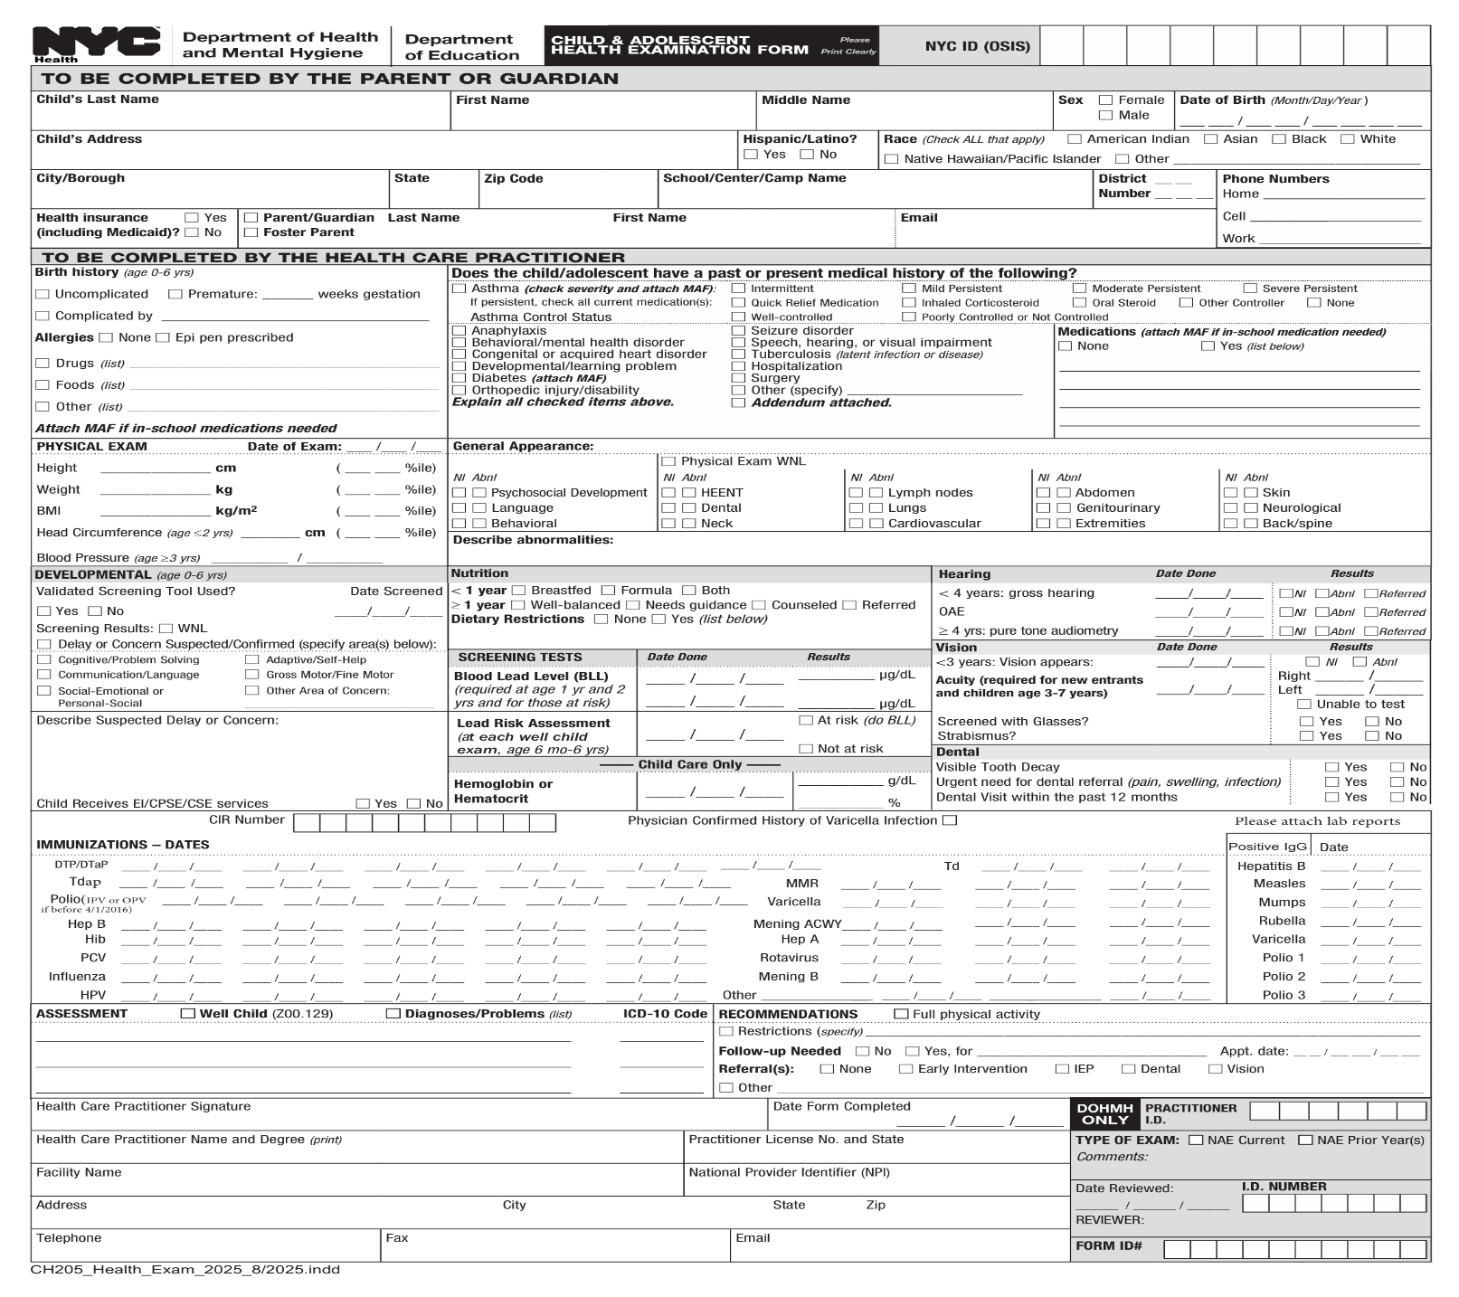

“Where Children Thrive, Learn through Play,
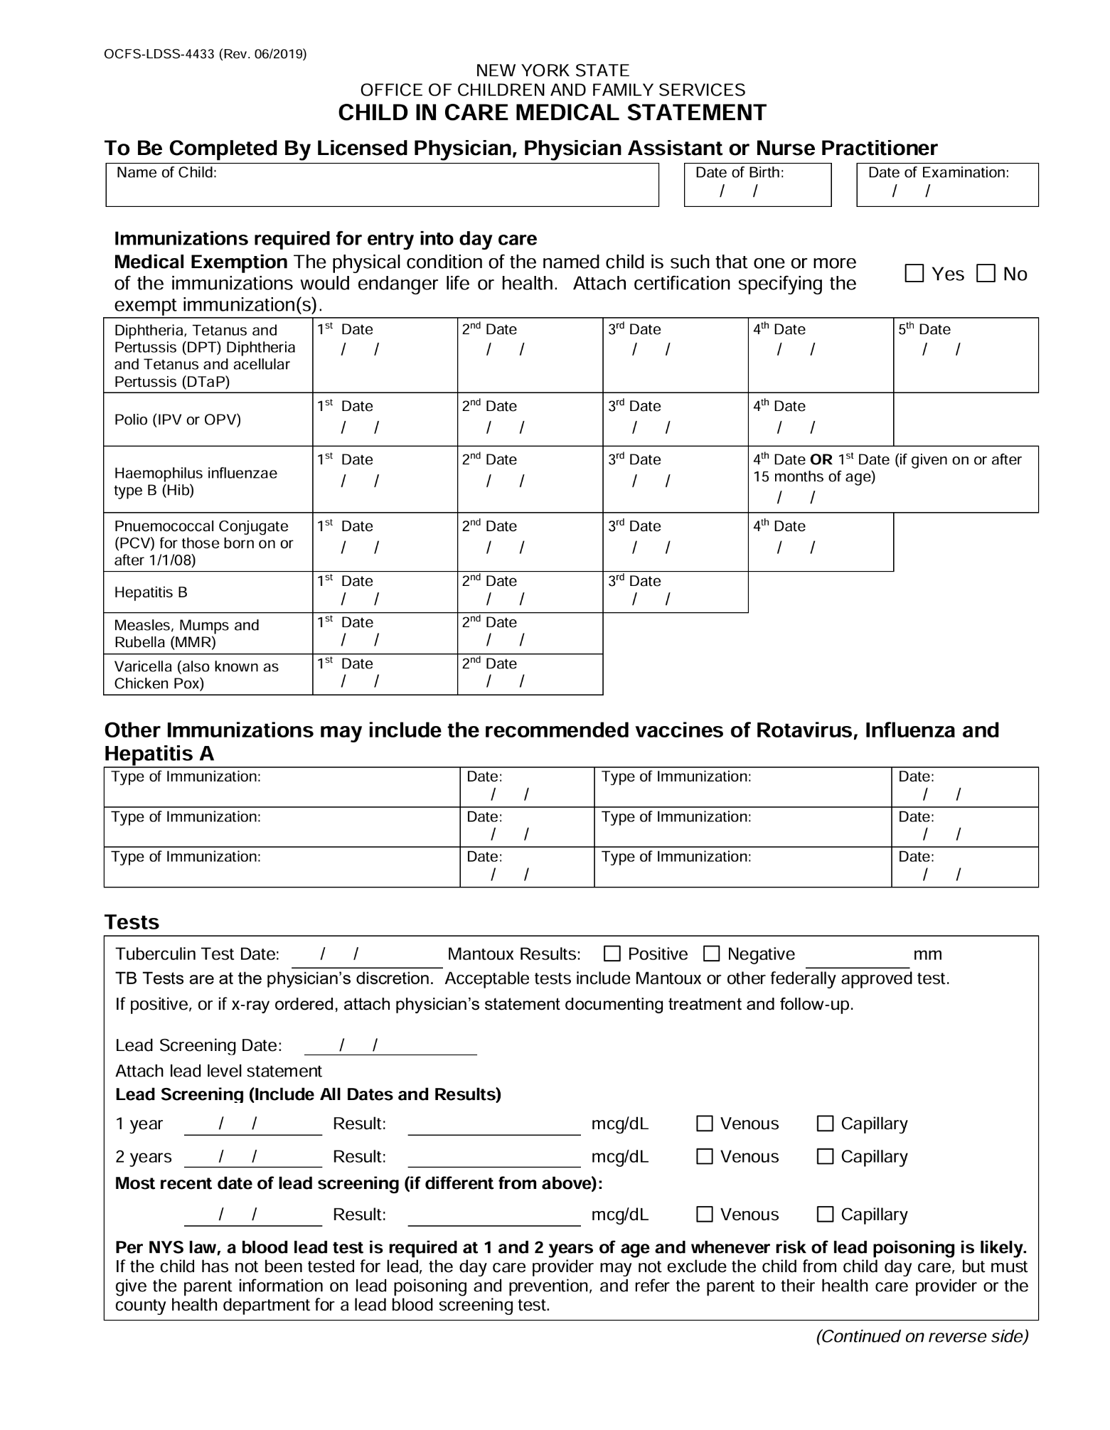
and Wonders and Extraordinary Awaits”
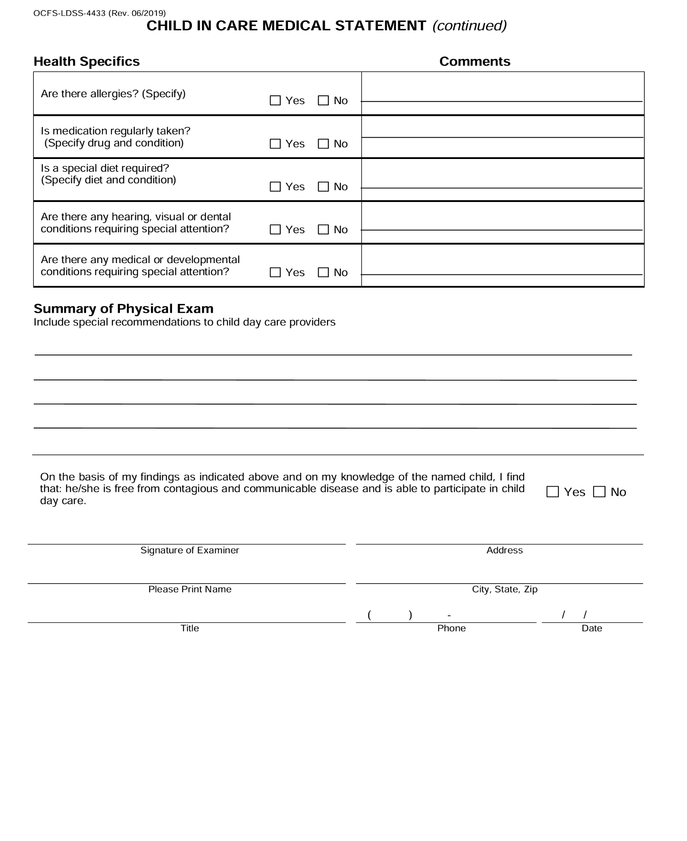

“Where Children Thrive, Learn through Play,
and Wonders and Extraordinary Awaits”

Afterschool/School Age Permission Slip for Photo Release Form

I, ________________________________________, the parent of ___________________________

at Blossoming Minds Child Day Care Afterschool/School Age agrees to the following:

I understand that my child(ren) whose name(s) are listed below may be photographed at the Blossoming Minds Early Childhood Family Center Afterschool/School Age during normal operating hours, field trips, or tasks/activities. I understand that these photographs may be used in promoting childcare services, either in print or on the Internet/daycare Website.

The child(ren) are known as: ____________________________________________________________________.

With my signature below I grant permission for my child(ren) to be photographed, or their images recorded for print or electronic use in promoting the Blossoming Minds Early Childhood Family Center Afterschool/School Age services. I understand that it is my responsibility to update this form in the event that I no longer wish to authorize the above uses. I agree that this form will remain in effect during the term of my child’s enrollment at Blossoming Minds Early Childhood Family Center Afterschool/School Age. I understand that there will be no payment for me or my child’s participation in this release.

Parent/Guardian Signature _____________________________ Date ______________________

Relationship To Child ______________________________________________________________

